NEW DIALING PROCEDURE FOR CUSTOMERS IN
82 AREA CODES IN 36 STATES!

FOR IMMEDIATE RELEASE
City, State (Date) –

On July 16, 2020, the FCC adopted an Order (FCC 20-100) approving 988 as the three-digit abbreviated dialing code to reach the National Suicide Prevention Lifeline starting July 16, 2022. The Order requires all telecommunications carriers, interconnected Voice over Internet Protocol (VoIP) providers, and one-way VoIP providers (covered providers) to make any network changes necessary to ensure that users can dial 988 to reach the existing National Suicide Prevention Lifeline by July 16, 2022.
In order for 988 to work in the 82 area codes in 36 states below, every customer with a number in those area codes with seven-digit local dialing must be transitioned to 10-digit (or 1+10-digit in CA and parts of IL). The FCC ordered that any area code that has the 988 prefix assigned as telephone numbers and has seven-digit local dialing be transitioned to 10-digit (area code + telephone number) or 1+10-digits (1+ area code + telephone number in CA and parts of IL) local dialing to ensure everyone is able to reach the National Suicide Prevention Lifeline using the three-digit 988 code.

Alaska | 907 | Minnesota | 218,952
Alabama | 251 | Mississippi | 662
Arkansas | 501 | Missouri | 314,417,660,816
Arizona | 480,520,928 | Montana | 406
California | 209,530,562,626,650,707,925 | Nevada | 775
 | 949,951 | New Hampshire | 603
Colorado | 719,970 | New Jersey | 856,908
Delaware | 302 | New Mexico | 505,575
Florida | 321(Brevard County only), 352,561, 941 | New York | 516,607,716,845,914
Georgia | 478,912 | North Carolina | 910
Guam | 671 | Ohio | 440,513
Hawaii | 808 | South Dakota | 605
Illinois | 309,618,708 | Tennessee | 731,865
Indiana | 219,574 | Texas | 254,361,409,806,830,915,940
Iowa | 319,515 | Vermont | 802
Kansas | 620,785 | Virginia | 276,804
Kentucky | 859 | Washington | 509
Louisiana | 337,504 | Wisconsin | 262,414,608,920
Michigan | 616,810,906,989

Beginning April 24, 2021, consumers with numbers in the area codes above should start dialing 10-digits (area code + telephone number or 1+10-digits (1+ area code + telephone number in CA and parts of IL) for all local calls. This is known as a permissive dialing period because if you forget and dial just seven-digits, your call will still be completed.

Beginning October 24, 2021, all consumers with numbers in the area codes above must dial 10-digits (area code + telephone number or 1+10-digits (1+ area code + telephone number in CA and parts of IL) for all local calls. On and after this date, local calls dialed with only seven-digits may not be completed, and a recording may inform you that your call cannot be completed as dialed. If you get this recording, you must hang up and dial again using the area code with the seven-digit telephone number.
What other changes need to be made?
Important safety and security equipment, such as medical alert devices, and alarm and security systems must be programmed to use 10-digit (1+10-digit) dialing. Many systems operate on 10-digit (or 1+10-digit) dialing by default but some older equipment may still use seven-digits. Please contact your medical alert or security provider if you are not sure whether your equipment needs to be reprogrammed to accommodate the upcoming change to 10-digit (or 1+10-digits) local dialing. Any needed reprogramming of alarm and home security equipment must be done during the permissive dialing period from April 24, 2021 to October 24, 2021 to avoid interruption of services. Some other examples of services that may need to be re-programmed are:
- life safety systems or medical monitoring devices
- PBXs
- fax machines
- Internet dial-up numbers
- fire or burglar alarm and security systems or gates
- speed dialers
- mobile or other wireless phone contact lists
- call forwarding settings
- voicemail services and other similar functions

Be sure to check your website, personal and business stationery, advertising materials, personal and business checks, contact information, your personal or pet ID tags, and other such items to ensure the area code is included.

What will remain the same?
- Your telephone number, including current area code, will not change
- The price of a call, coverage area, or other rates and services will not change due to the dialing change
- What is a local call now will remain a local call regardless of the number of digits dialed
- You will continue to dial 1+ the area code + telephone number for all long-distance calls
- You will continue to dial a prefix (such as “9”) when dialing from a multi-line telephone system (e.g., in a hotel, office building, etc.) as required
- You can still dial just three digits to reach 711 (relay services) and 911 (emergency services)
- If 211, 311, 411, 511, 611, 711 or 811 are currently available in your community, dial these codes with just three digits
- The National Suicide Prevention Lifeline can still be reached by dialing 1-800-273-TALK (8255) even after the 988 code is in effect

Beginning July 16, 2022, dialing “988” will route your call to the National Suicide Prevention Lifeline. Customers must continue to dial 1-800-273-8255 (TALK) to reach the Lifeline until July 16, 2022.
You may visit the North American Numbering Plan Administrator (NANPA) website at https://www.nationalnanpa.com/transition_to_10_digit_dialing_for_988/index.html or email NANPA at 988@somos.com with questions about the dialing procedure change, or you may visit the FCC website at https://www.fcc.gov/suicide-prevention-hotline.
Following are maps for all of the states affected by this dialing change. Areas in blue represent area codes changing to 10-digit (or 1+10-digit) dialing. Areas in yellow are not affected by this change.
Alaska Alabama
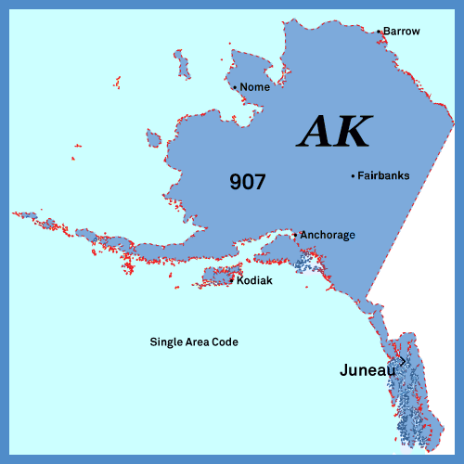
Arizona Arkansas
California
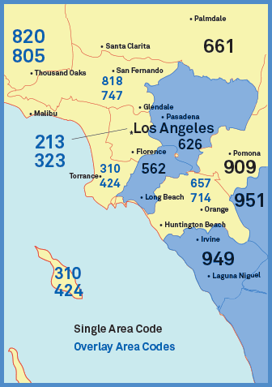
Colorado Delaware
Florida Georgia
Guam Hawaii
Illinois Indiana
Iowa Kansas

Kentucky Louisiana
Michigan Minnesota
Mississippi Missouri
Montana Nevada

New Hampshire New Jersey
New Mexico New York
North Carolina Ohio
South Dakota Tennessee

Texas Vermont
Virginia Washington
Wisconsin

