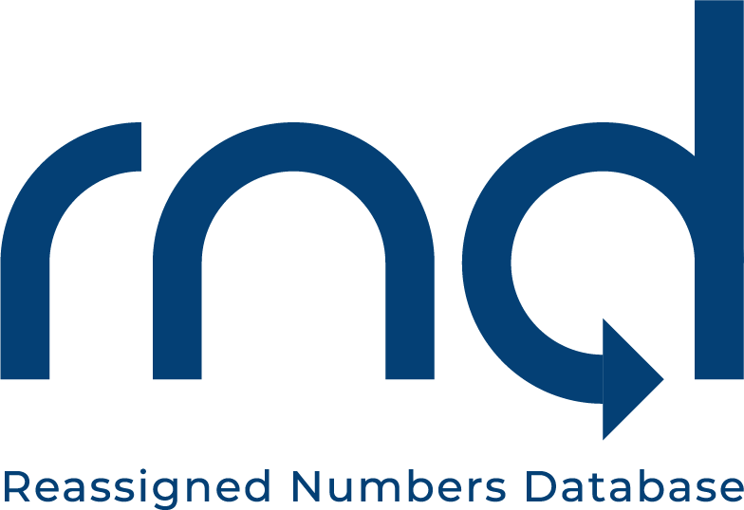

Date: March 3, 2021
Subject: Reporting of Initial Data to the Reassigned Number Database (RND) Attached Agenda and Submit Guide Posted
To: Service Providers Reporting Permanent Disconnected Telephone Numbers
*****
As a reminder, the RND Administrator will be hosting a webinar event on March 5, 2021 (11:00 am -12:30 pm Eastern) and a repeat of the event on March 12, 2021 (11:00 am -12:30 pm) to discuss the submission process, review a short demonstration, and answer questions. This event will be for Service Providers and/or Service Provider Agents who are required to submit permanently disconnected telephone numbers to the RND. The event will also be recorded for those that cannot attend either the March 5 or March 12th dates. An Agenda is attached.
More detail on the submission process can be found in the March 2, 2021 DRAFT RND User Guide-Submitting Disconnected Telephone Data, which can be downloaded from the NANPA website at https://nationalnanpa.com/ The document is posted on the homepage under “What’s New”.
The logistics are as follows:
You are invited to a Zoom meeting.
When: Mar 5, 2021 11:00 AM Eastern Time
Register in advance for this meeting:
https://somos.zoom.us/meeting/register/tJwlcu6hrDgvGNBTz2rmo8kslrbC61nXyxyJ

After registering, you will receive a confirmation email containing information about joining the meeting.
Or
You are invited to a Zoom meeting.
When: Mar 12, 2021 11:00 AM Eastern Time (US and Canada)
Register in advance for this meeting:
https://somos.zoom.us/meeting/register/tJwqf-6rpjstGdMu8KRdbXdxuI4os6UbNZ4B

After registering, you will receive a confirmation email containing information about joining the meeting.

Please make sure employees involved with the RND are subscribed to receive the NANP notifications ("Other" Non-Geographic Notifications) regarding upcoming RND activities. Subscription to the notices can be done directly through the NANPA website at https://nationalnanpa.com/contact_us/mailing_list.html

If you have any questions, please contact Beth Sprague at 571-363-3821,
bsprague@reassigned.us or support@reassigned.us

Sincerely,

Beth Sprague
Director, RND

